

“May the Lord watch between me and thee, while we are absent one from the other”

Beta Sigma Phi  
  
In Memoriam Ritual

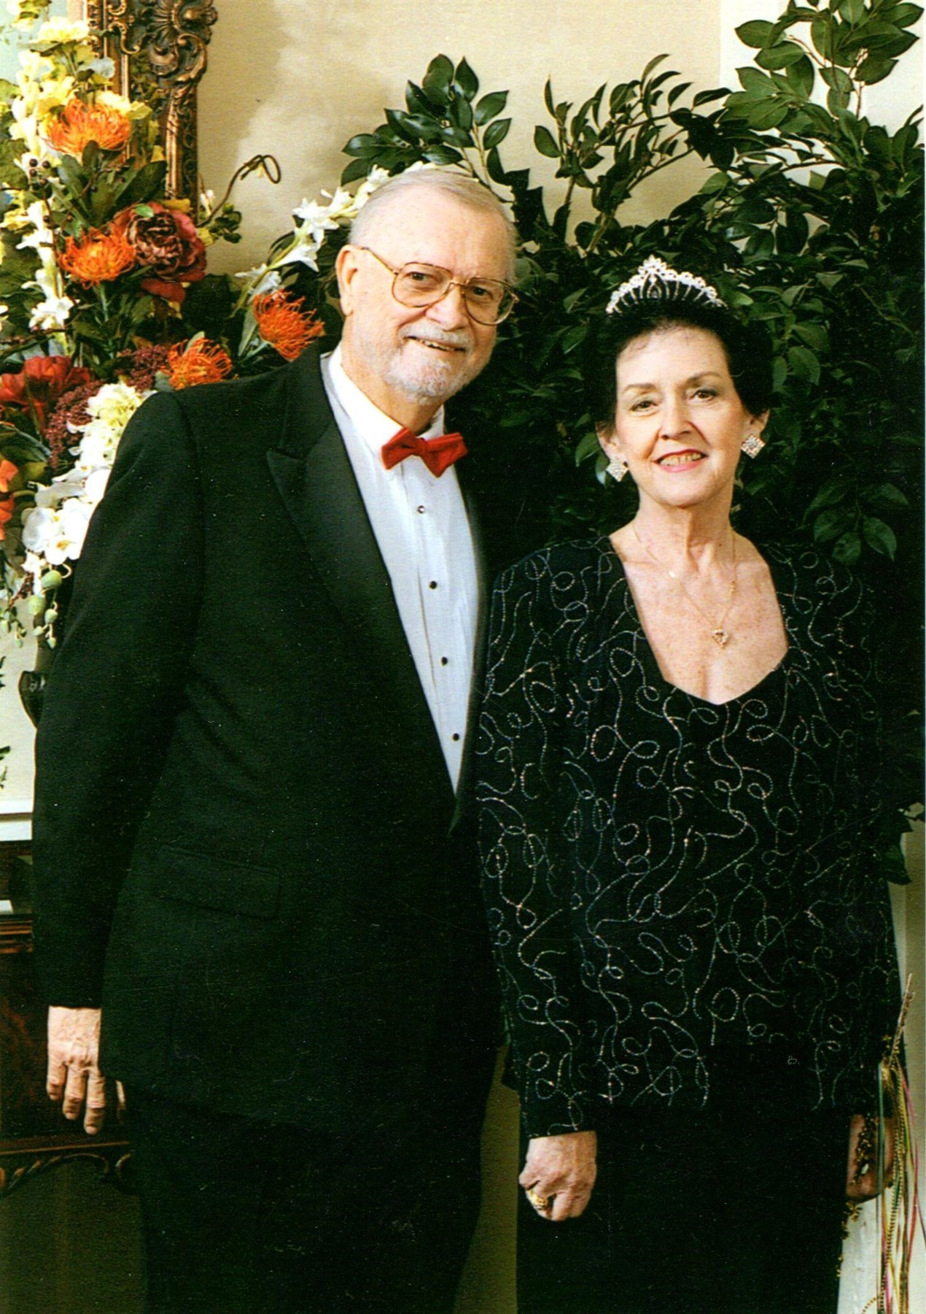

In Memory of  
our beloved sister  
Sally Martha Vrba  
  
May 6, 1935 - July 28, 2017

**Β Σ Φ**

C:\Users\Sharon\AppData\Local\Microsoft\Windows\INetCache\Content.Word\Colored Crest.jpg

**Life, Learning, Friendship**

Beta Sigma Phi Sorority is an international women’s’ friendship network and the largest organization of its kind in the world with over 165,000 members in over 5,700 chapters. It was founded in 1931 by Walter Ross in Abilene, Kansas. Our organization then and now offers women social, cultural and service opportunities as well as friendship and support for each other.

Our symbol is the Yellow Rose which denotes friendship.   
  
Houston City Council of Beta Sigma Phi has 15 chapters and approximately 150 members.

This Ritual was conducted   
on   
August 3, 2017   
at   
Earthman Southwest Funeral Home  
Stafford, Texas  
by  
Sharon Johnson Munn  
President  
Houston City Council  
of  
Beta Sigma Phi



The torch of our sisterhood lighted her way on earth, but she hath now no need for sun or moon. But we have need to keep forever bright within our hearts the memory of her living presence.

Speech cannot contain our Love.

She was, she is, our sister.

https://tse1.mm.bing.net/th?id=OIP.vJYx0q-QZqQ9h7aH0kMNAQEsAl&pid=15.1&P=0&w=307&h=39

Sisters, please join me in repeating our Closing Ritual and Mizpah followed by each of you placing your rose on the table and returning to your seats.

**Closing Ritual**Eternal Father, Shepherd of the Stars, guide us that we may follow only the Good, the True only the Beautiful. Hold aloft to us the guiding torch of wisdom and help us to push on, undaunted toward its light. Illume our souls with thy wisdom that we in turn may light the way for those who follow us. If the road we take seems obscured in dust, give us skill and grace to pave it with stars, to transmute the dust into stardust. Grant us such clearness of vision, such sweetness of sprit, such earnestness of purpose, that we may follow the torch to our goal.



At this time, would the sisters in Sally’s chapter, Lambda Master, please come forward with their yellow roses form a semi-circle.

Now would other Beta Sigma Phi sisters please come forward with their yellow roses and join the semi-circle with our Lambda Master sisters.

https://tse1.mm.bing.net/th?id=OIP.vJYx0q-QZqQ9h7aH0kMNAQEsAl&pid=15.1&P=0&w=307&h=39

Dearly Beloved: We are gathered together today in sorrowing sisterhood to consecrate in our hearts and memory the life and virtues of a dearly departed member, Sally Vrba, who was a member of Lambda Master Chapter.

Sally joined Beta Sigma Phi in October 1966. She held all chapter offices and served on all committees, her favorite being Scrapbook Committee where she created intricately beaded covers that her sisters still cherish. Sally was selected Queen of our council in 2001. She held the Order of the Rose and Silver Circle along with many more honors during her 50 years in our sorority. She held the Torchbearer Degree, the highest degree in Beta Sigma Phi. Sorority was a major part of Sally’s life.

As she stood before in Darkness, initiate, so stands she now initiate to the mystery of Death, and we in the somber shadows of our grief.



The flowing torch of her bright self must be henceforward absent from us here, but the clear light of her spirit shall remain, undimmed, to guide and strengthen us whom she preceded.

In life, she was devoted to the good, the true and the beautiful, and was by color, form and music touched to tears. With loyal heart and with unflagging effort she faithfully fulfilled her duties here. Then being weary for a moment she lay down to rest, using her burden for a pillow and fell into that dreamless sleep that kisses down her eyelids still. While yet in love with life and raptured with the world she passed to timeless silence and to formless space.

So, every life, no matter if its every hour be rich with love and every moment jeweled with joy, must, at its close become to those who stay, a tragedy as sad and dark as can be woven of the wrap and woof of mystery and death.

But in this night of death hope sees a star and listening love can hear the rustling of a wing.

She was a faithful and true friend, a treasure inestimable in possession, and deeply lamented in the loss. If we in her lifetime were not always worthy of her love, let us now in her death resolve to be more worthy of the love of all other members of our sisterhood.

Nothing is more common than to talk of a friend, nothing more difficult than to find one, nothing more rare than to improve by one as we ought. She has taught us it is best to live in time as friends to those with whom we would be all eternity, for true friendship is infinite and immortal.

The record of generous life runs like a vine around her memory, and her every sweet, unselfish act is now a perfume flower. Were everyone to whom she did a service to bring a blossom to her grave she would sleep tonight beneath a wilderness of flowers.

Life is a narrow vale between two eternities. We strive in vain to look beyond the heights. But through the mist of our tears the light of love beholds a rainbow, the rainbow of her virtues:



The red of her courage,  
The orange of her loyalty,   
The yellow of her vision,  
The green of her fellowship,  
The blue of her humility,  
And the violet of her service.

Character survives, goodness lives, love is immortal.