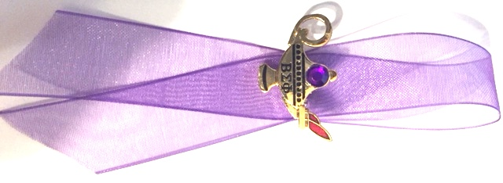

First ritual was conferred Founder’s Day, April, 1976   
to seventeen past presidents of Houston City Council   
by Virginia Lee, President Elect (1975-1976)

Houston City Council

of

Beta Sigma Phi

“JEWEL RITUAL”

for

Outgoing  
HCC President

**OFFICIANT:** We are assembled now to pay special honor to one among us for whom the violet ray of Services shines with its greatest intensity. Though she as our chosen leader and in that capacity exhibited all the virtues representative of Beta Sigma Phi, the essence of leadership is service. It is Service free from self to and for those who are led.

In the performance of her duties she has displayed, Courage, meeting every challenge with Vision. She has shown Humility, denying for herself the whole credit for fine accomplishments and grand experiences, while being confident of our own contributions. She has accepted the responsibility and the privilege of expanding her horizons beyond her own close fraternal group, enabling her to represent and care for each of us as individuals and each chapter whose efforts this City Council is meant to coordinate. Rising above her own special desires and the interests of her own chapter, she has recognized the fellowship which draws us all togetherand makes possible cooperation and the unified effort which are required to discharge our joint purposes and goals.

Exhibiting all these virtues and in all these ways she has served us well, it is now our pleasure to confer upon her this special honor, recognizing her always as a jewel – one special gem which like the diamond combines the lift of all the gems into clear, white light in which all things may be seen clearly and the way ahead is made plain.

Do you, _______________________, now accept this special honor and this further opportunity to serve your sisters in Beta Sigma Phi? If so, answer “I do”.

**OFFICIANT:** You are now and here forth will always be known as a Jewel of Houston City Council of Beta Sigma Phi.

[Officiant hands the Outgoing President her “Jewel” pin]

Congratulations!

Congratulations.

**INSTRUCTIONS:** This Ritual is given to the Outgoing President at Founder’s Day after the Installation of New Officers. The setting for this ritual should be the same as for the installation of officers as described in the ΒΣΦ “Book of Rituals.” The Ritual Certificate is matted with a Purple Mat (representing Service), framed, signed and dated at the bottom by the President-Elect (Incoming President). The Outgoing President’s Name and the Sorority Year are printed at the top of the Certificate. An editable copy of this Certificate can be found on HCC’s Website under “Flyers, Forms and Procedures.” The Crest of Beta Sigma Phi Sticker (ordered from the BSP International Gift Catalog) is adhered to the left side of the Certificate. The “Lamp of Knowledge” Pin can be ordered from Epsilon Phi Master chapter (Contact: Alice White) and is paid for by Houston City Council. The purple gem (for service) is not part of the purchased pin. It is glued with “jewelry glue” onto the pin. The completed pin is pinned to a 5/8” purple sheer ribbon for presentation. The purple ribbon is pinned on the Outgoing President with a corsage pin that has a purple glittered head. A copy of this Jewel Ritual Booklet is given to the outgoing President for her scrapbook.

**The President-Elect is the   
Officiant of this Ritual**.